EASTERN INTERNATIONAL UNIVERSITY Practice Assignment – Quarter 1, 2025- 2026
SCHOOL OF COMPUTING Course Name: Special Topic 1
AND INFORMATION TECHNOLOGY Course Code: CSE 484
aa Student’s Full Name: Hà Quang Minh
Lab 5
Student ID: 1931220012

Background

Required Resources:
- Postman desktop app (latest version)
- Internet connection
- Use pure HTTP GET requests + JavaScript in Postman to extract real data from an url without any backend or scraping tool.

Questions:
Step 1: Preparation
- Open Postman → Create new Collection Named: EIU Website Extractor Lab
- Create new Environment named “EIU_Lab” with variables:
base_url = https://eiu.edu.vn/en current_date = {{$todaysDate}}
- (Optional) Create Newman CLI script “run_eiu_lab.js” const newman = require('newman');
newman.run
({
collection: './EIU Website Extractor Lab.postman_collection.json', environment: './EIU_Lab.postman_environment.json',
reporters: ['html', 'cli']
});
My Solution:
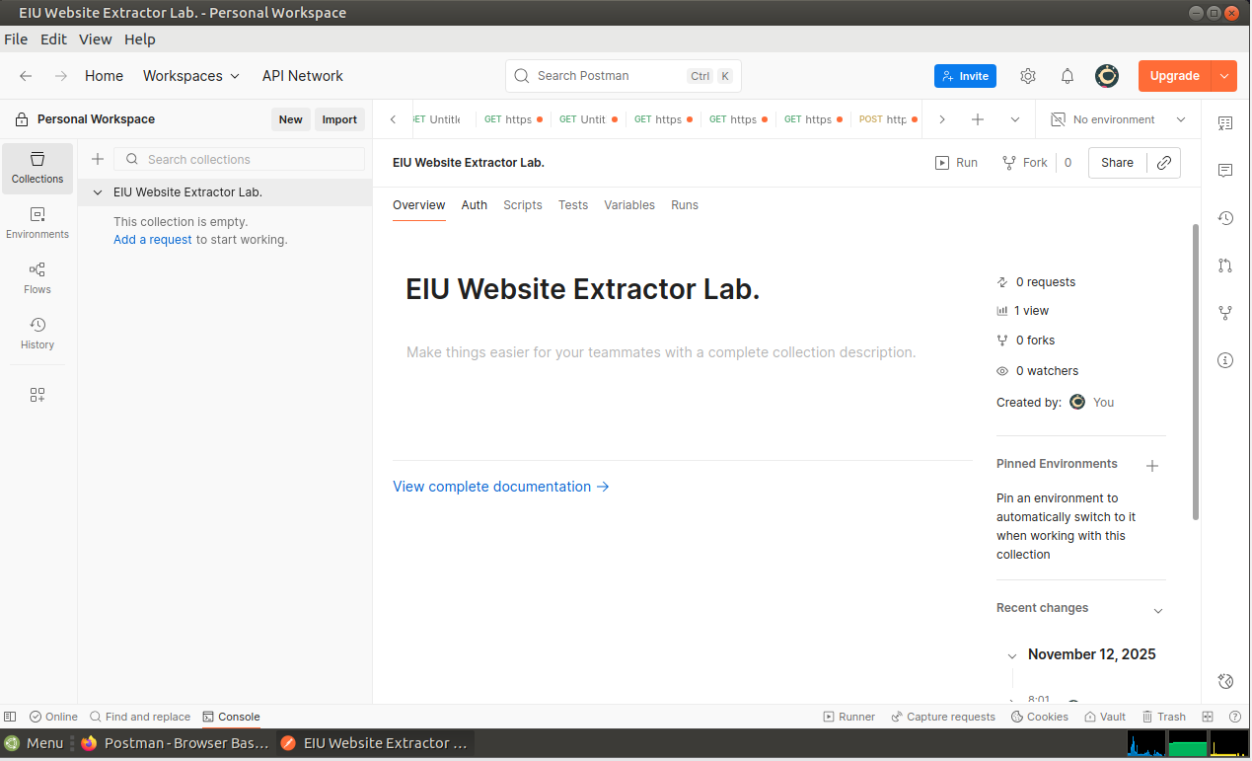
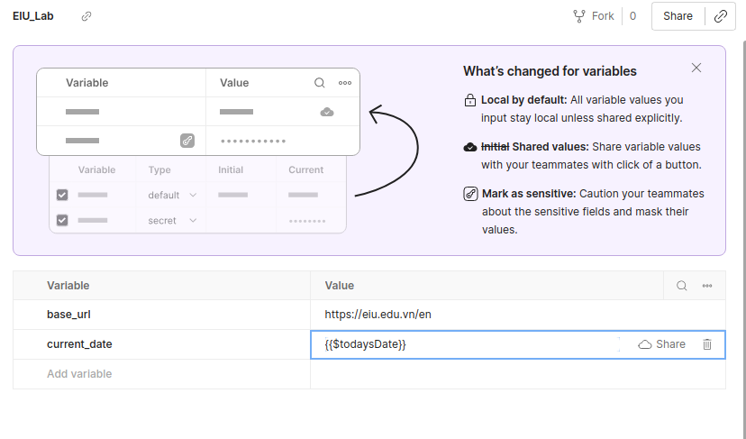
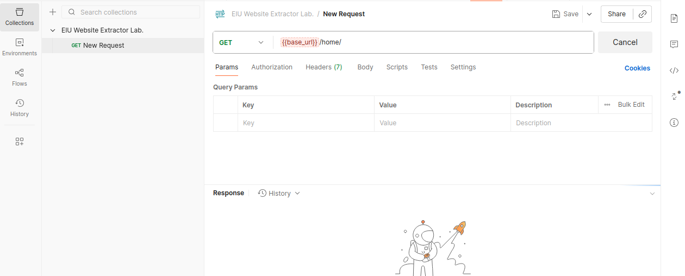
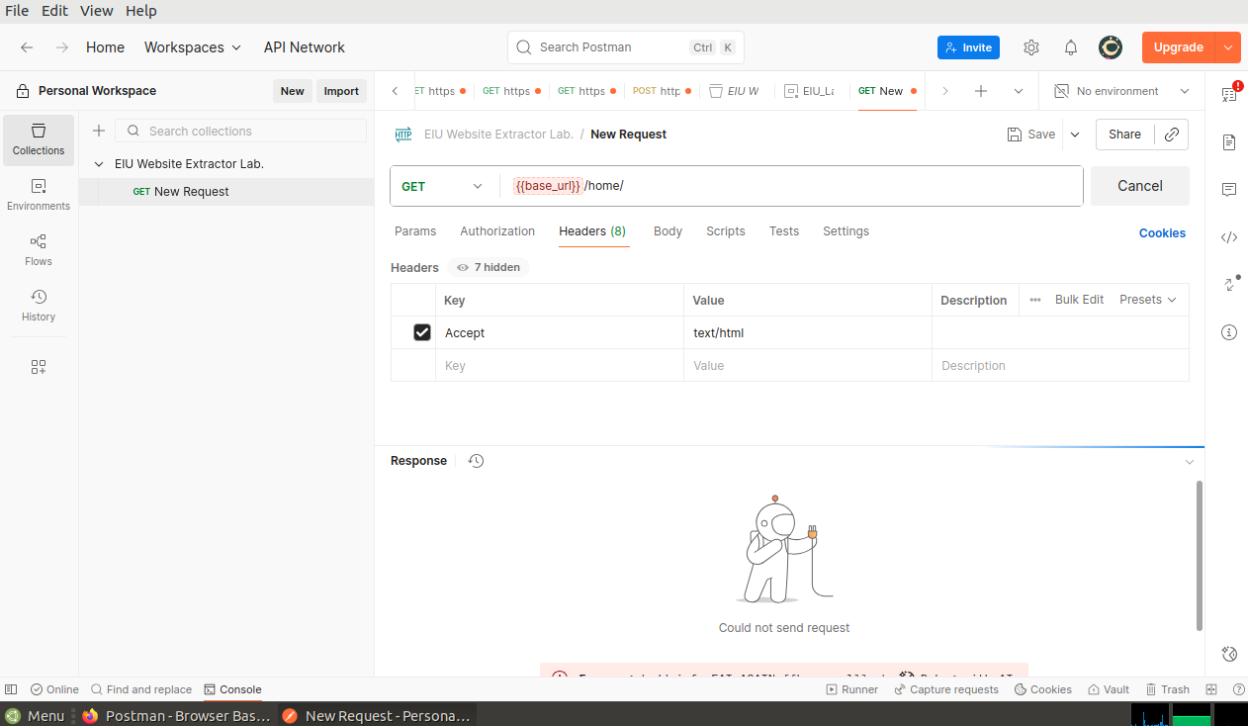
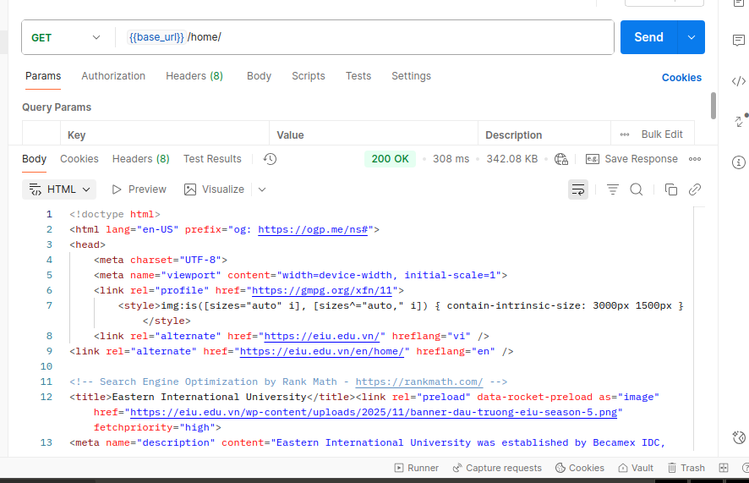
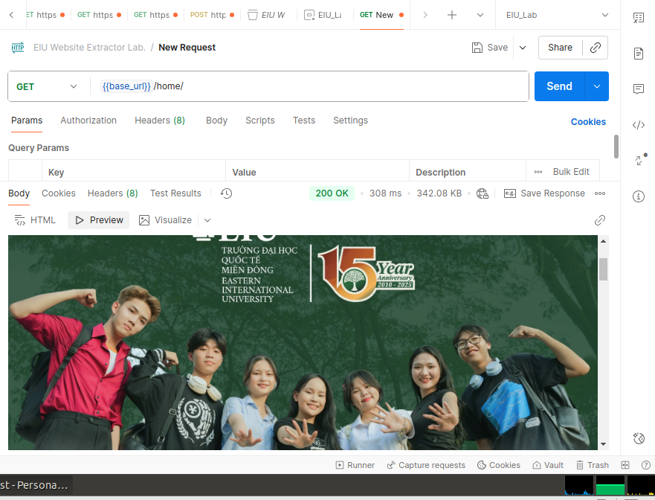
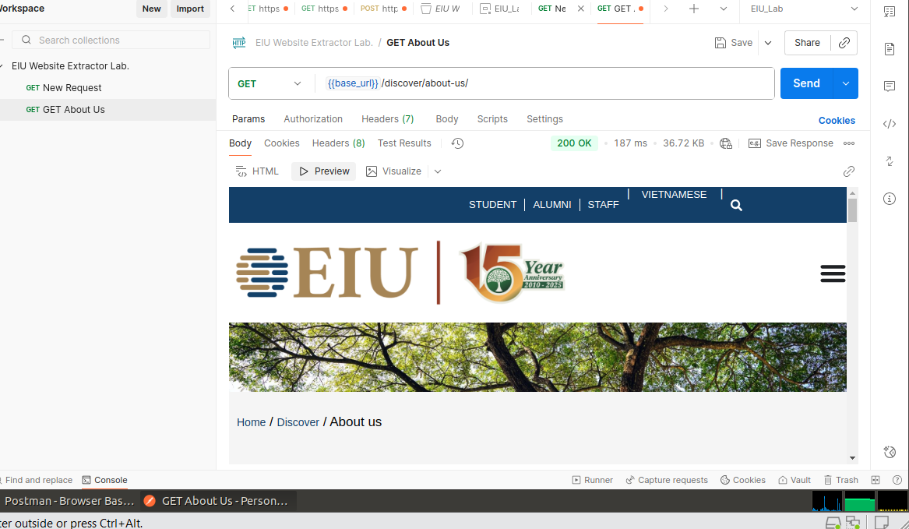
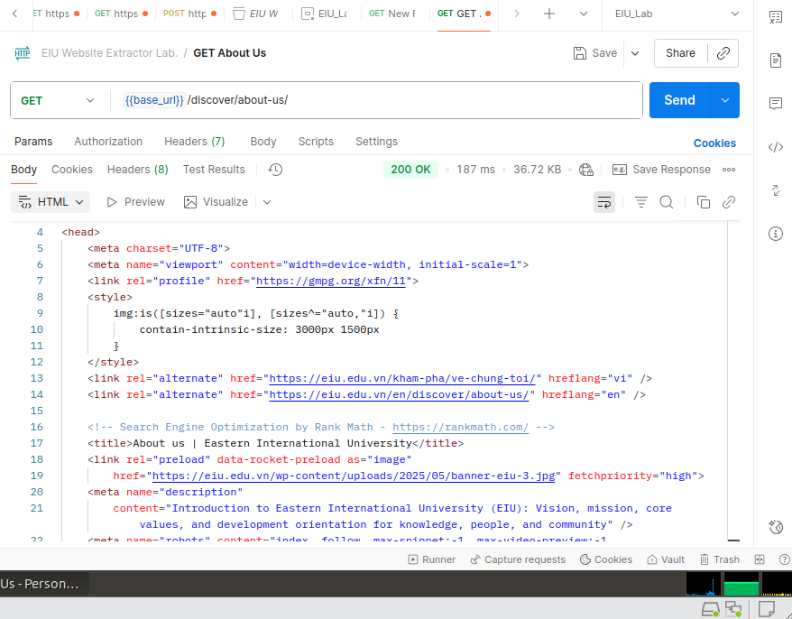

Step 2: Extract Basic Info from Homepage

Goal: Get page title, meta description, and main menu items.
- New request → Name: GET Homepage

  - Method: GET
  - URL: {{base_url}}/home/
  - Headers → Add: Accept: text/html
  - Send
- Test tab (JavaScript)
pm.test("Status code is 200", function ()
{
pm.response.to.have.status(200);
});
pm.test("Response time < 1000ms", function ()
{
pm.expect(pm.response.responseTime).to.be.below(1000);
});
const html = pm.response.text();

// Extract <title>
const titleMatch = html.match(/<title>(.*?)<\/title>/i); const title = titleMatch ? titleMatch[1].trim() : "Not found"; console.log("University Name: " + title); pm.environment.set("school_name", title);

// Extract meta description
const descMatch = html.match(/<meta name="description" content="(.*?)"/i); const description = descMatch ? descMatch[1] : "Not found"; console.log("Description: " + description); pm.environment.set("school_desc", description);

// Extract main menu (Discover, Study, etc.)
const menuItems = html.match(/<a href="\/en\/discover[^>]+>(.*?)<\/a>/g) || []; console.log("Main Menu (first 5):", menuItems.slice(0,5));
Result: University Name: Eastern International University (EIU) Description: EIU offers dual-objective study programs...
My Solution


Step 3: Extract History & Location from About Us Page
- New request → Name: GET About Us URL: {{base_url}}/discover/about-us/ Send
- Test tab:
pm.test("About page loaded", function () { pm.response.to.have.status(200); pm.expect(pm.response.text()).to.include("established");
});
const html = pm.response.text();

// Founded year
const yearMatch = html.match(/established in (20\d{2})/i);

const year = yearMatch ? yearMatch[1] : "Not found"; console.log("Founded Year: " + year); // 2010 pm.environment.set("founded_year", year);

// Location
const locationMatch = html.match(/(Ho Chi Minh City|Thu Duc City|Becamex)/i); const location = locationMatch ? locationMatch[0] : "Not found"; console.log("Location: " + location);
pm.environment.set("location", location);

// Employment rate
const rateMatch = html.match(/(\d+)% graduate employment/i); const rate = rateMatch ? rateMatch[1] : "Not found"; console.log("Employment Rate: " + rate + "%"); pm.environment.set("employment_rate", rate);

Chain from Step 2 → Add to Tests of Step 2: (javascript)
postman.setNextRequest("GET About Us");
My Solution




Step 4: Extract List of Academic Program
- New request -> Name: GET Programs URL: {{base_url}}/study/
Send
- Test tab:
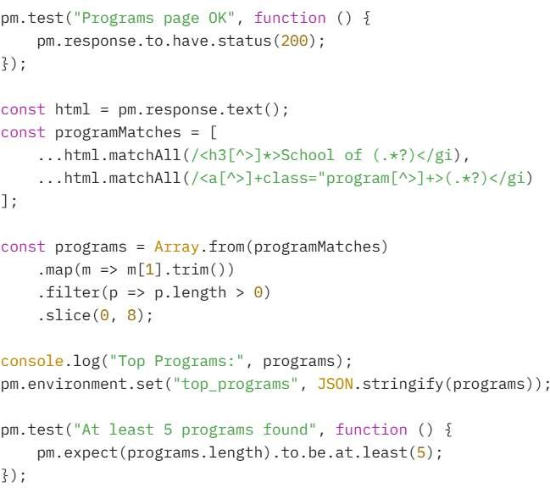

  - Result: (json)
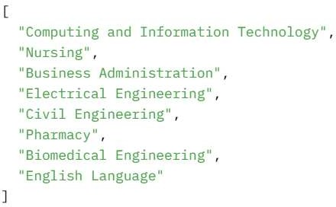
My Solution
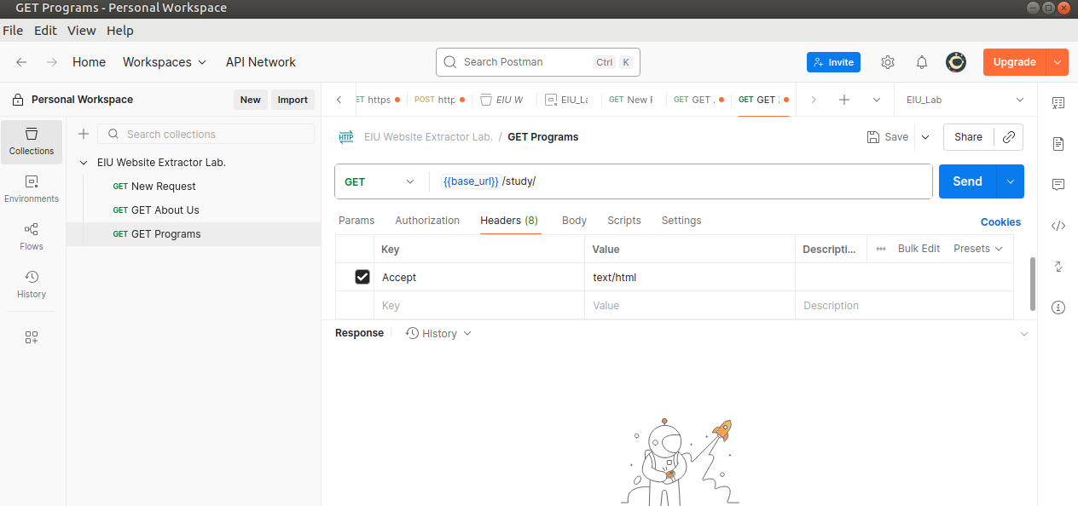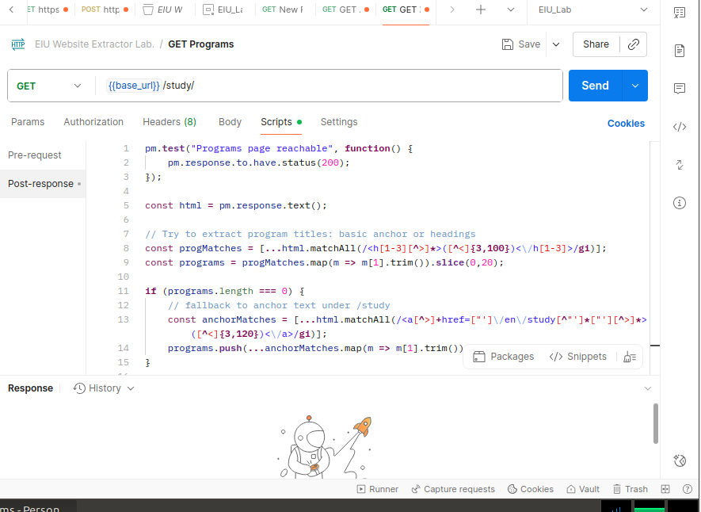
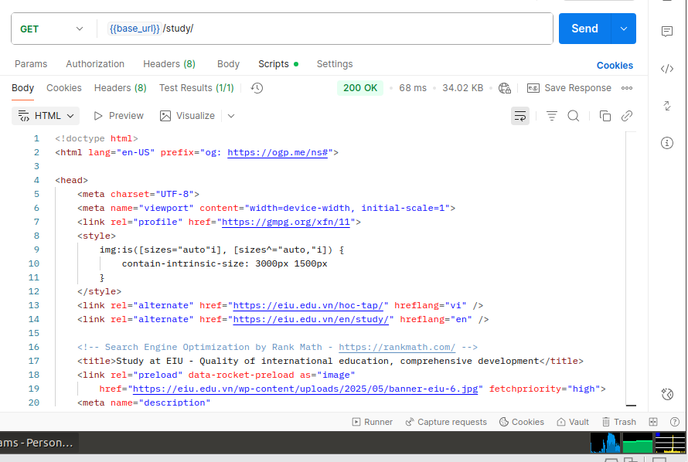
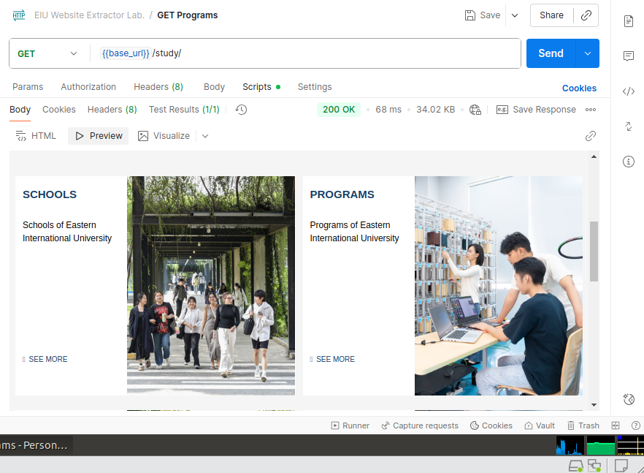

Step 5: Extract Admission Info & Contact
- New request → Name: GET Admission & Contact URL: {{base_url}}/apply/
Send
- Test tab: (javascript)
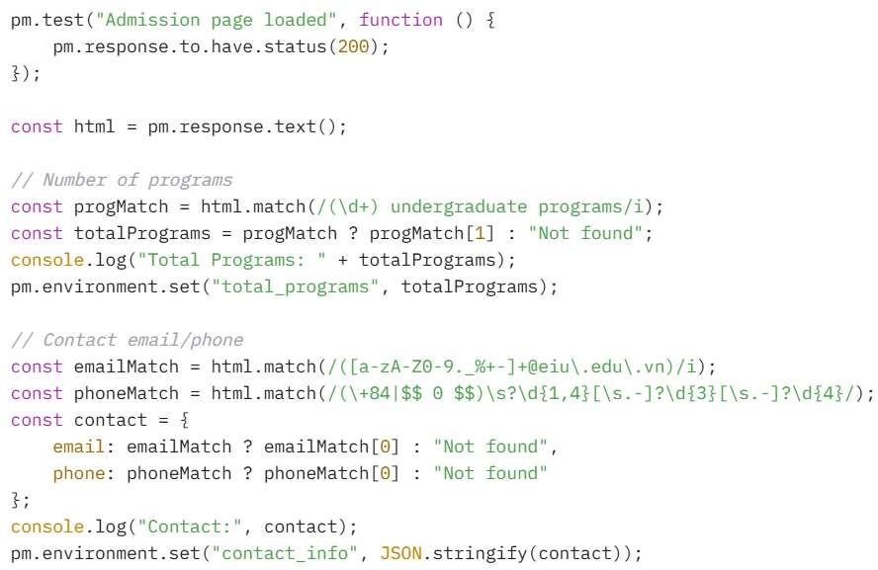

Chain -> Add to Step 4 Tests:
postman.setNextRequest("GET Admission & Contact");

My Solution

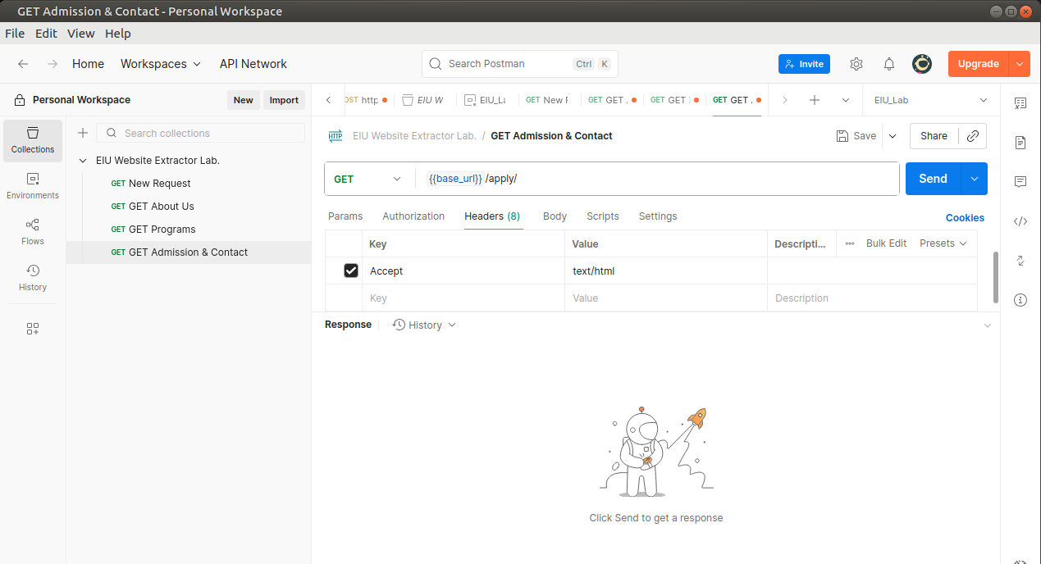
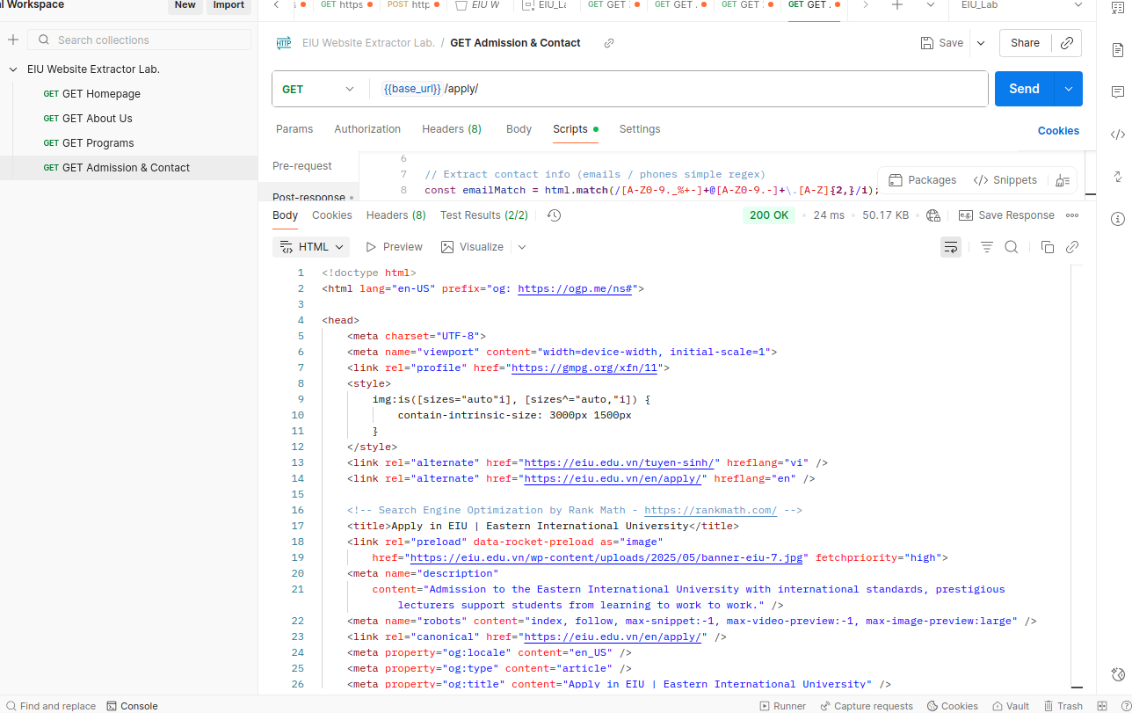
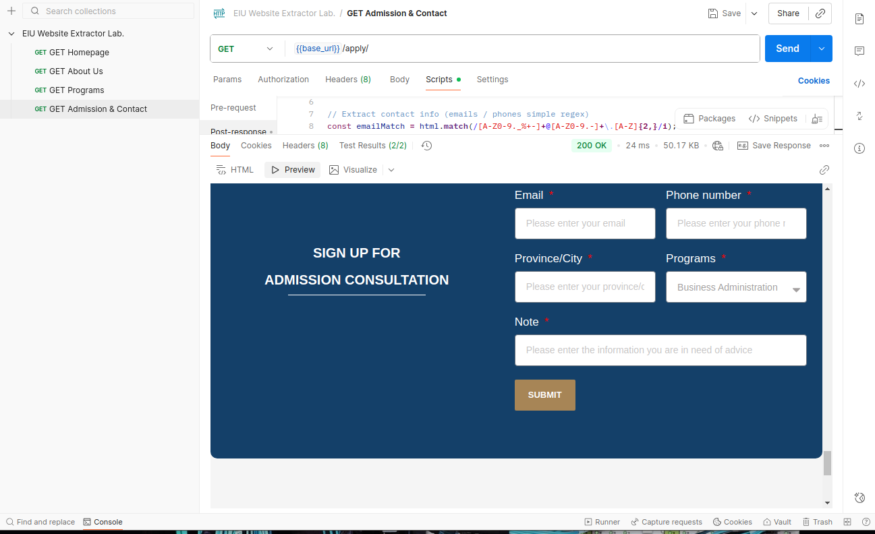

Testing
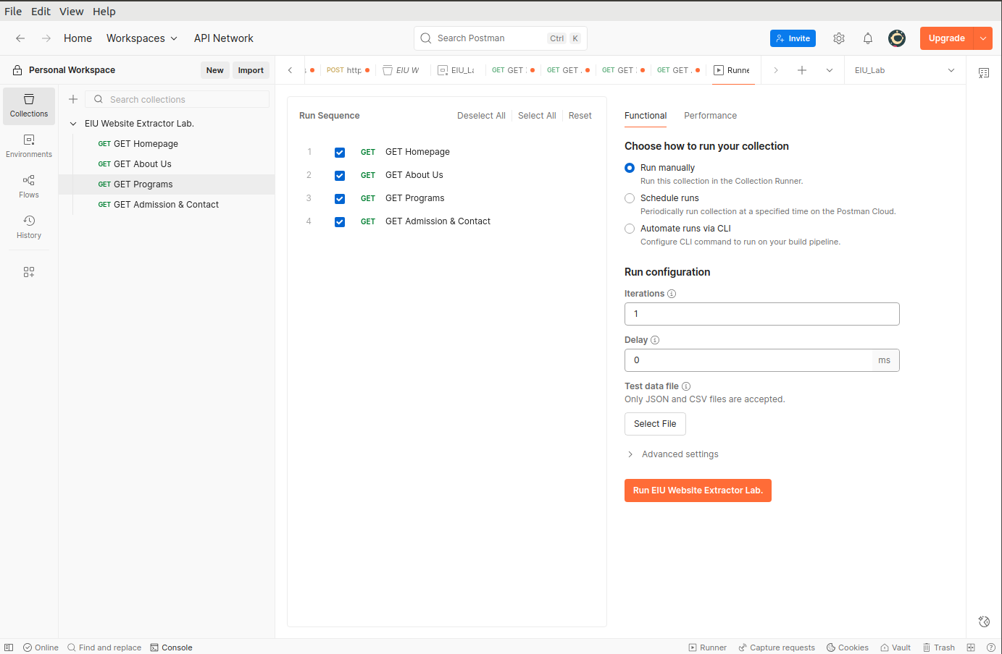
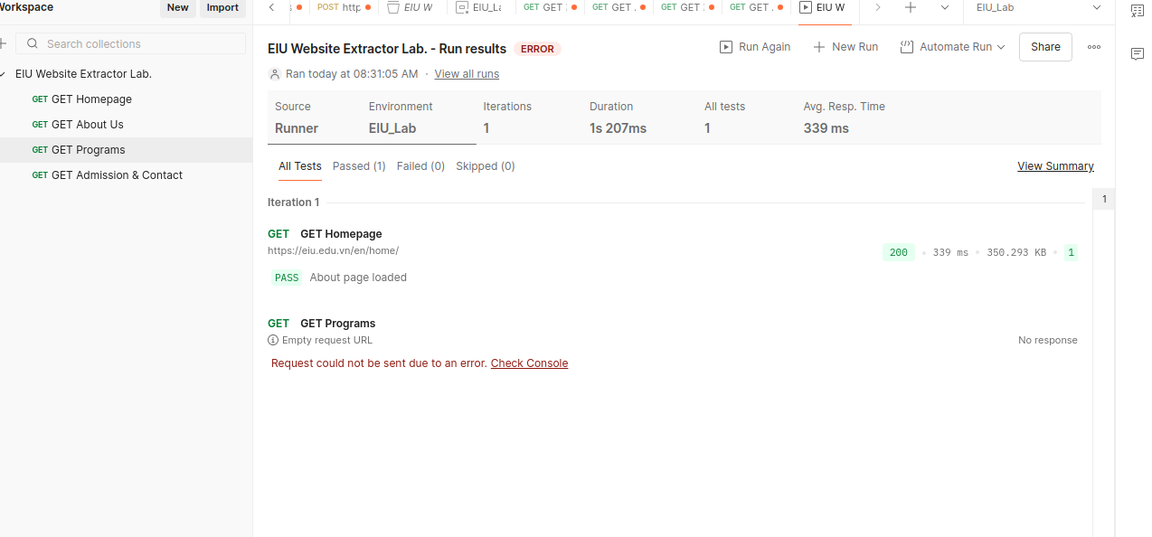
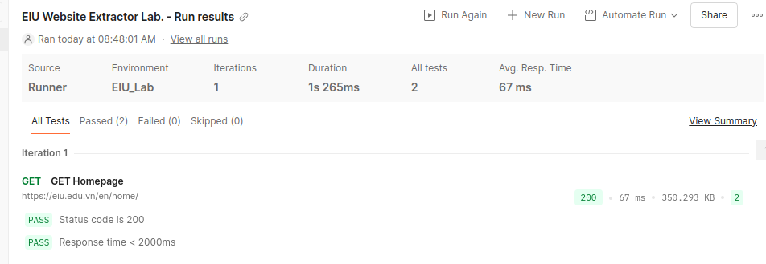

STEP 6: Run Full Automation & Generate Report

- Open Collection Runner
  - Select all 4 requests
  - Iterations: 1
  - Delay: 500ms
  - Run
- Check result: 4/4 passed, average < 600ms
- Export → HTML Report → Submit to lecturer
- Environment variable after run:
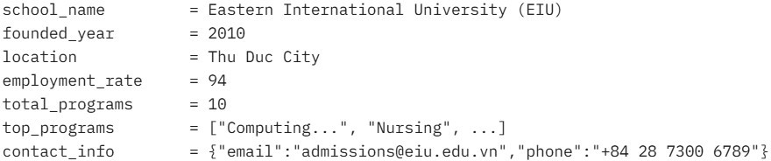

Expected Outcomes

**Postman Lab Report – EIU Website Extractor** Student: Class: Date: {{$todaysDate}}
**Results**:
- Total Requests: 4
- Passed: 4/4 (100%)
- Avg Response Time: ms
- Extracted Data:
- Name: {{school_name}}
- Founded: {{founded_year}}
- Location: {{location}}
- Employment Rate: {{employment_rate}}%
- Total Programs: {{total_programs}}
- Contact: {{contact_info}}
**Screenshots attached**: Console + Environment + HTML Report

Submission: Must include:
  - a pdf report file containing your information (student id, name), and images of the diagrams, codes, answers, evident,…
  - and all source code files (if any)
in a zipped (.zip or *.rar) file to Moodle

